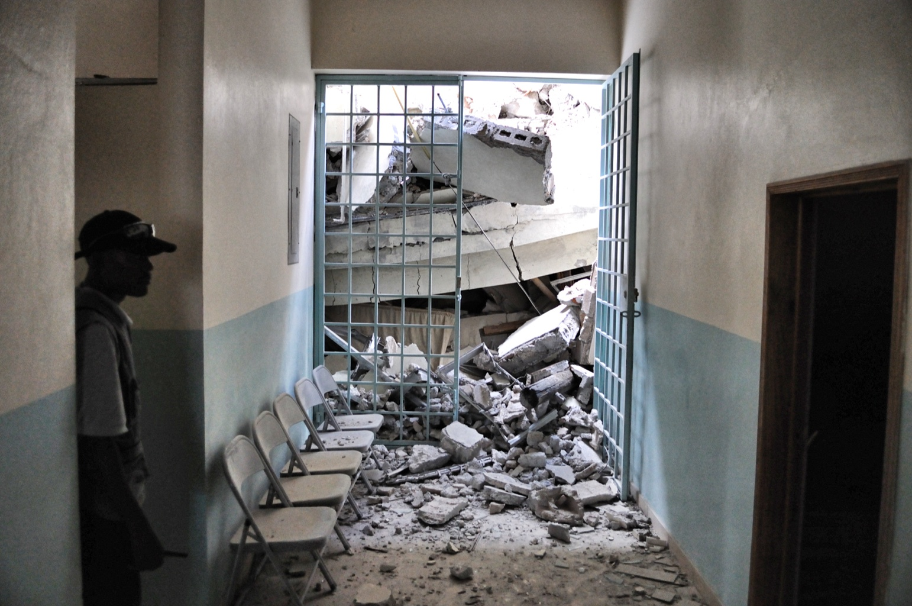
Implementation Workbook Editable Forms

Developing Messages for Protective Actions
to Take During Earthquake Shaking

March 2018

Copyright © GeoHazards International 2018

Creators of imagery used herein retain all rights to their images.

Worksheets in this document may be freely distributed for noncommercial use, provided that the source is acknowledged.

Use of the survey instruments in this workbook must be in accordance with internationally recognized ethical standards and applicable national laws and policies for human subjects research.

This document is made possible by the generous support of the American people through the United States Agency for International Development (USAID) Office of Foreign Disaster Assistance (OFDA) under Grant No. AID-OFDA-G-15-00240.- The contents are the responsibility of GeoHazards International and do not necessarily reflect the views of USAID or the United States Government.

The material presented in this document should not be used for any specific application without competent examination by qualified professionals for its suitability and applicability to local conditions. Users of information from this publication assume all responsibility and liability arising from its use. GeoHazards International and USAID assume no responsibility for the accuracy of opinions expressed herein.

Contents
Introduction 4
Project Planning Worksheet 5
Message Development Committee Worksheet 7
Local Experiences Worksheet 10
Local Beliefs and Customs Worksheet 11
Population Exposure Worksheet 12
Gender Considerations Worksheet: WOMEN 13
Gender Considerations Worksheet: MEN 14
Vulnerable Population Groups Worksheet 15
Communication Channels Worksheet 16
Communication Products Worksheet 17
Communication Campaign Planning Worksheet 18
Local Seismic Hazard Worksheet 19
Local Buildings Worksheet 20

Introduction

GeoHazards International (GHI) prepared the tools in this workbook as part of a USAID Office of Foreign Disaster Assistance (OFDA)-funded project to implement protective actions guidance developed in an earlier USAID/OFDA project. The implementation project took place in Anse-a-Veau, Nippes Department, Haiti. The Government of Haiti selected this location because the south peninsula region had not had prior earthquake safety programs, and an ongoing earthquake swarm was causing great concern among local residents. Earlier versions of the worksheets in this document were used in the Anse-a-Veau implementation, and subsequently revised based on that experience. The examples in this workbook were prepared based on the Anse-a-Veau implementation.

These tools are intended to support local protective actions message development. When using these worksheets, please acknowledge the source.

Project Planning Worksheet
Instructions
The project planning worksheet is meant to be completed by the project team. The purpose is to clearly identify the project management team members and their roles, the geographic area to be covered by the project, and establish the goals, scope and timeline for the project.

Project Title: ___________________________________________________________________
Project Time Period: ____________________________________________________________

Project Location: _______________________________________________________________

Project Objectives: ______________________________________________________________
____________________________________________________________________________________________________________________________________________________________
Project Team Members:

____________________________________
____________________________________
____________________________________
____________________________________
____________________________________
____________________________________
____________________________________
____________________________________

Project Partners:

____________________________________
____________________________________
____________________________________
____________________________________
____________________________________
____________________________________
____________________________________
____________________________________

Project Activities:

______________________________________________________________________________________________________________________________________________________________________________________________________________________________________________________________________________________________________________________________________________________________________________________________________

Message Development Committee Worksheet
Explanation and Instructions
The Message Development Committee Worksheet is meant to be completed by the project team. The purpose is to help the project team identify all important stakeholders and ensure that all the necessary consideration are being made during the messaging development. The Message Development Committee should include people representing each of the following:

Affiliation and Technical Background | Messaging Consideration | Contribution to Messaging | Examples
Organization(s) that will communicate the message | Geographic area or jurisdiction | Geographic area and national context, target area characteristics | Representative(s) of national, state or provincial disaster management agency or civil protection agency, local NGO, UN agency, or INGO
Social science | Beliefs, traditions, customs | Identify potential conflicts with proposed messages or that would affect a person’s ability to take protective action; suggest strategies to address barriers | Academic, local leader, or specialist from NGO
Local demographics | Population exposure | Explain where people are located, and when. Speak to needs of groups of people whose livelihood or occupation puts them at unique and high risk; in coastal areas this includes tsunami risk | Local government planning employee; community representative, and if needed, representative of fishing/maritime or mining association
Structural engineering | Local buildings | Knowledge of building stock and earthquake vulnerability, building codes and enforcement, construction quality, can speak to likelihood that buildings will collapse | Professional engineer or academic; may need more than one depending on how many types of buildings and how narrowly specialized the local engineers may be
Earth science | Local earthquake and related hazard | Up-to-date detailed information on local earthquake hazard and site conditions | Professional or academic; may need more than one to cover site conditions and tsunami, landslide hazard
Women | Gender and age vulnerability | Issues faced by women and those frequently in their care(elderly and children), such as tendency to be in hazardous building type or cultural norms affecting ability to take protective actions | Women representative of the local community, local women’s organization representative
Communications/  Public Relations/ Marketing | Create and disseminate messages | Guide content into message forms; develop strategy to communicate in the community | Government public information officer, marketing or advertising professional; journalist
Local government | Major stakeholder | Explain government’s concerns; support the messaging through input and outreach | Civil protection, jurisdiction administration representative
Public health or medicine | Health effects of earthquakes | Understand how local buildings can kill or injure and interpret epidemiological and medical studies | Epidemiologist or emergency medicine/ trauma specialist
Functional and access needs specialist | Needs of people that may need to take different actions | Recommend how main message may need to be customized to meet functional and access needs of all populations | Representative of organization working with people with mobility, sensory or cognitive impairments, preferably with specific needs themselves
Local institution representatives | High occupancy and institutional settings | Recommend how main message may need to be customized for high occupancy or institutional settings | School administrator, hospital administrator,  religious leader

Message Development Committee Worksheet
Template
Name & Contact Information | Affiliation | Technical Background | Messaging Consideration | Contribution to Messaging

Local Experiences Worksheet
Instructions
This worksheet provides a place to record local experiences with earthquakes and natural disasters that can be leveraged to achieve adoption of protective actions by the community. Experiences can include past earthquakes, earthquake exercises, or other natural disasters. Add rows as needed.

Why collect this information?
People’s past experience will give you insights into how they will respond to future events. Understanding how people reacted and how the experienced changed them, will provide insights about how to leverage the experience in disseminating messages.

Experience | Who had this experience? | What did people do? | What did they learn? | How to leverage?

Local Beliefs and Customs Worksheet
Instructions
This worksheet provides a place to record local beliefs and customs that may present barriers to adoption of protective actions by the community, or alternatively, could enhance adoption of protective action. Beliefs and customs could originate in religious beliefs, traditions, cultural values, superstitions, misiniformation, etc. Add rows as needed.

Belief or Custom | Type of belief/custom? | Group(s) holding this belief/custom? | How will this belief/custom affect if people believe or perform the recommended action? | How to address these barriers or make positive use of this belief/custom?

Population Exposure Worksheet

Instructions
This worksheet provides a place to record information about where different population groups are at different times. People’s vulnerability may change depending on where they are throughout the day. It may be necessary to account for these variations in messaging. Consider whether differences in gender, age, occupation or other characteristics place people in locations where they are more vulnerable. Try to make generalized observations for population groups, as there will always be variations in individual people’s situations. In coastal areas, complete a separate worksheet for tsunami exposure.

Time of Day |  | For each population group, list where most people in the group are at the specified time of day? | Are there any groups with increased vulnerability? | How should messaging be modified to account for this vulnerability?
Weekdays | Morning
 | Afternoon
 | Night
Weekends | Morning
 | Afternoon
 | Night
Holidays | Morning
 | Afternoon
 | Night
Other time of day :

Gender Considerations Worksheet: WOMEN

Instructions
This worksheet provides a place to record factors specific to women that may affect their ability to adopt protective actions. An all-women group should complete this worksheet. Add rows as needed.

What things make this group more vulnerable to disasters?  (location, mobility, cultural, access to information, occupation, etc.) | What factors would affect this group’s ability to take protective actions?  (mobility, etc.) | How would protective actions guidance be modified to overcome these barriers? | What factors would affect this group’s ability to receive messaging about protective actions? (education, literacy, access to information, etc.) | How should this be accounted for in message dissemination?

Gender Considerations Worksheet: MEN

Instructions
This worksheet provides a place to record factors specific to men that may affect their ability to adopt protective actions. An all-men group should complete this worksheet. Add rows as needed.

What things make this group more vulnerable to disasters?  (location, mobility, cultural, access to information, occupation, etc.) | What factors would affect this group’s ability to take protective actions?  (mobility, etc.) | How would protective actions guidance be modified to overcome these barriers? | What factors would affect this group’s ability to receive messaging about protective actions? (education, literacy, access to information, etc.) | How should this be accounted for in message dissemination?

Vulnerable Population Groups Worksheet

Instructions
This worksheet provides a place to record factors for other population groups that are more vulnerable in earthquakes and may not be able to take the recommended protective actions. Add rows as needed.

Population Group | What makes this group vulnerable to earthquakes?  (location, mobility, cultural, access to information, occupation, etc.) | What factors would affect this group’s ability to take protective actions?  (mobility, etc.) | How would protective actions guidance be modified to overcome these barriers? | What factors would affect this group’s ability to receive messaging about protective actions? (education, access to information, literacy) | How should this be accounted for in message dissemination?

Communication Channels Worksheet

Instructions
This worksheet provides a place to identify communication channels for message dissemination. Add rows as needed.

Communication Channel | Audience | Advantages | Disadvantages | Details for local channels

Communication Products Worksheet

Instructions
This worksheet provides a place to identify communication products that could be used for message dissemination. Add rows as needed.

Product | Channels | Advantages | Disadvantages | Relative Cost (Low, Moderate, High)

Communication Campaign Planning Worksheet

Instructions
This worksheet provides a place to enter basic information needed to develop a communications campaign plan for message dissemination. In addition, the campaign plan should specify the following for each communication product: who is responsible, the schedule and deadlines, and resources necessary to both develop and disseminate the product.

Campaign name:

Campaign Objective:

Campaign Coordinators:

Campaign Budget:

Campaign Duration:

Campaign Dates:

Campaign Message(s):

Target audience(s):

Campaign Partners:

Local Seismic Hazard Worksheet

Instructions
This worksheet provides a place to record information about the local seismic hazard. This worksheet should be completed beforehand with an earthquake expert familiar with the geographic region. Include references to maps or information sources.

Fault Locations
List active faults that can generate earthquakes affecting the area
Earthquake History
List historic and pre-historic earthquakes affecting region
Soil Types
Describe soils and how they may amplify shaking
Time to take protective actions
Estimate S-minus-P time for various sources (see Hough, 2014)
Secondary Hazards
Includes tsunami, fire, landslides, dam or levee failure, release of hazardous materials

Local Buildings Worksheet

Instructions
This worksheet provides a place to record information about local buildings. This worksheet should be completed beforehand with a structural engineer familiar with the buildings in the geographic region. Add rows as needed.

Building Type | Where are these buildings found? | Are these buildings vulnerable to collapse? | Where are the safest places inside these buildings? | Where are the danger zones in these buildings? | Are there safe open spaces outside most buildings? | Are there enough exits for all people inside building?

